Morongo Band of Mission Indians Load Assessment

Morongo Resort Casino & Spa (MCRS)
49566 Seminole Dr.
Cabazon, CA 92230

Account # 700939779894; Service Account # 8019628307
Rate: TOU-8-D
Solar Online Date: 26-Nov-24

The following section presents the load assessment for the Morongo Resort Casino & Spa (MCRS). Monthly energy consumption from December 2024 through February 2026 is illustrated in Figure 1. Reported values reflect net energy consumption in kWh, accounting for on-site solar generation, and represent billed usage from Southern California Edison (SCE). Notably, net consumption becomes negative during May, June, and July 2025, indicating that solar generation exceeded total site energy demand during these months. For 2025:
- Total Energy Consumption: 921,552 kWh
- Total Energy Costs: $875,317

Despite strong solar production, total electricity costs remain high. This is primarily driven by demand charges, which are based on peak power usage (kW), rather than total energy consumption (kWh). Demand charges represent the largest cost component of the MCRS electric bill. For example, in December 2024, demand charges accounted for 71% of the total bill (Table 3). This highlights a key issue, even when solar reduces total energy consumption, it does not necessarily reduce peak demand, which drives costs.

Under SCE’s TOU rate structure solar generation is credited only within the time period it is generated and excess generation during low-value periods (e.g., super off-peak) provides limited financial benefit. Analysis of Figure 3 shows excess solar production occurs during summer off-peak periods (8 AM – 4 PM) and winter super off-peak periods (12 PM – 4 PM, 9 PM – 12 AM). However peak pricing occurs during on peak and mid peak hours 4 PM – 9 PM, when solar production is minimal or zero. This creates a structural mismatch between generation and cost savings.
Peak Demand Profile
- Summer Peak Demand: 1,280 kW (August)
- Winter Peak Demand: 1,184 kW (March)
These peaks drive substantial demand charges regardless of total energy usage. MCRS is energy-rich (due to solar), but still cost-constrained due to demand peaks and TOU misalignment.

Figure 1: MCRS Monthly Energy Consumption by Year
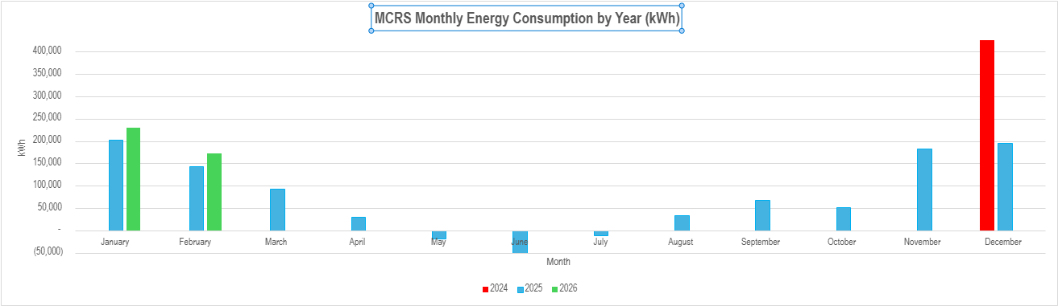
Figure 2: MCRS Monthly Energy Bills
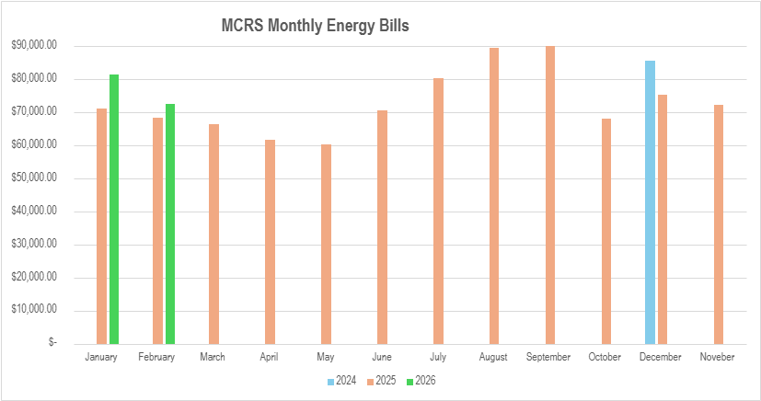

Figure 3: 2025 MCRS Monthly Energy Consumption
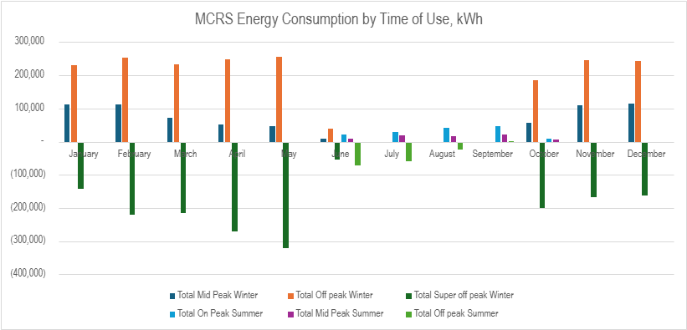
Table 1: Electric Bill Seasonality & Time of Use Definitions
Summer (Jun 1-Sep 30) |  |  |  | Winter (Oct 1-May 31)
 | Weekdays | Weekend & Holidays |  |  | Weekdays | Weekend & Holidays
on peak | 4pm-9pm |  |  | mid peak | 4pm-9pm
mid peak |  | 4pm-9pm |  | off peak | 12am-8am | 12am-4pm
off peak | 12am-4pm | 12am-4pm |  |  | 9pm-12am | 9pm-12am
 | 9pm-12am | 9pm-12am |  | super off peak | 8am-4pm | 8am-4pm

Table 2: Electricity Rates, $/kWh
Rates, $/kWh |  | Mid Peak | Off Peak | Super off peak | On Peak
Delivery Charges
 | Winter | 0.020505 | 0.019272 | 0.018505
 | Summer | 0.017840 | 0.017630 |  | 0.018950
Generation Charges
 | Winter | 0.070446 | 0.071051 | 0.037429
 | Summer | 0.083370 | 0.056500 |  | 0.091145
Figure 4: 2025 MCRS Summer Demand, kW
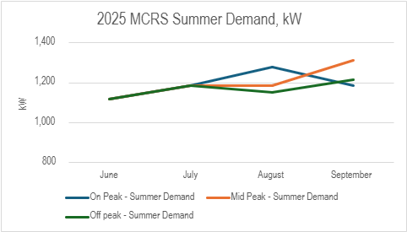
Figure 5: 2025 MCRS Winter Demand, kW
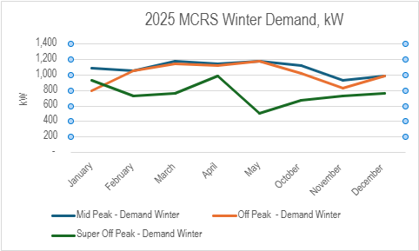

Table 3: Morongo Demand Charges for December 2024
Month | kW Demand Delivery Charges |  |  |  |  |  | kW Generation Charges |  |  |  | DMD Charges |  | Total Charge |  | % of Total
 | Winter |  |  | Summer |  |  | Winter |  | Summer
 | Facilities Rel. DMD | Mid Peak | Facilities Rel. DMD |  | On peak | Mid Peak |  | on peak
Dec-24 | $4,904 | $604 | $22,795 |  | $16,323 | $1,127 |  | $15,331 |  | $61,084 |  | $85,588 |  | 71%
Recommendations to Consider
- Rate Optimization - evaluate alternative SCE tariffs (if available) and assess eligibility for demand response programs
- Operational Strategy - Shift flexible loads into solar production hours and reduce simultaneous high-load events
- Assess peak demand management opportunities and implement load control strategies such as HVAC optimization, smart building controls and equipment scheduling
- Assess the cost/benefits of adding Battery Energy Storage System (BESS) to decrease peak demand

Tukwet Golf Club
Address: 36211 Champions Dr., Beaumont
Account # 700929334513; Contract #: 8018946592
Rate: TOU-EV-8
Solar Online Date: 4-Oct-24
The following presents the load assessment for the Tukwet Golf Club. See Figure 6 for monthly energy consumption from October 2024 through February 2026. The values shown reflect net energy consumption after accounting for solar generation and represent the usage recorded on Southern California Edison bills. Notably, consumption becomes negative in May and June 2025, indicating that solar generation exceeded total site energy use during those months. See Figure 7 for the monthly energy bills. The 2025 Total Energy Consumption =22,547 kWh and Total Energy Bills = $14,674.45.

Figure 8 presents monthly energy consumption by Time-of-Use (TOU) period. Negative values indicate periods when solar generation exceeds on-site energy demand. During the winter months, the system produces significant excess energy during super off-peak hours; however, due to net metering rules, this excess generation cannot fully offset consumption during other TOU periods, such as off-peak hours. Although Tukwet receives credits for the surplus energy, these credits are applied at super off-peak rates, which are the lowest-value rates. Recommendations to consider shifting flexible loads and assess cost/benefits of adding battery energy storage.
Figure 6: Tukwet Monthly Energy Consumption by Year
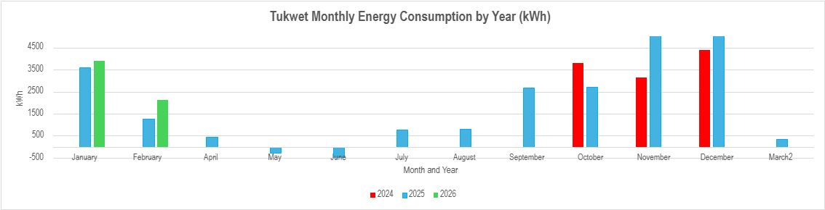
Figure 7: Tukwet Monthly Energy Bills
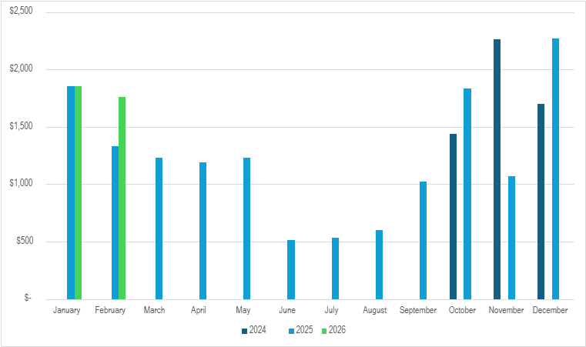
Figure 8: Tukwet Monthly Energy Consumption by Year
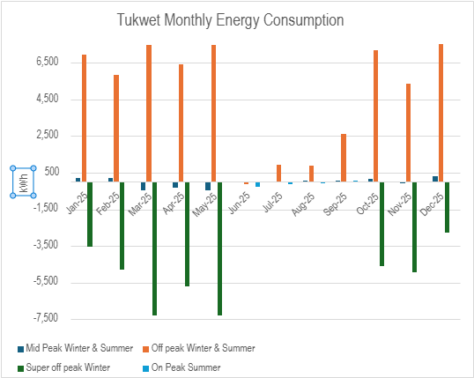
Summer
Jun 1- Oct 1
Table 4: Electricity Rates, $/kWh
Rates, $/kWh |  | Mid Peak | OffPeak | Super off peak | On Peak
Delivery Charges
 | Winter | 0.276016 | 0.124869 | 0.055642
 | Summer | 0.254110 | 0.116360 |  | 0.254110
Generation Charges
 | Winter | 0.150220 | 0.094914 | 0.041021
 | Summer | 0.095040 | 0.073620 |  | 0.333640
Figure 9: Tukwet Monthly Energy Demand
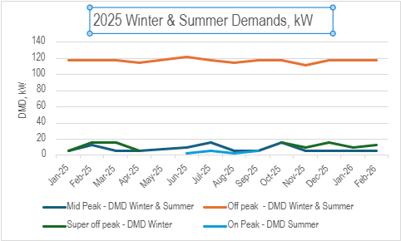

Community Center
13000 Malki Road
Account #: 700875505371; Contract #: 8017538218
Rate: TOU-GS-2-D
Solar Online Date: 18-Mar-24
The following presents the load assessment for the Community Center; see Figure 3 for monthly energy consumption. The values shown reflect net energy consumption after accounting for solar generation and represent the usage recorded on SCE bills. Available billing data is limited for the period from 2021 through 2023; however, it clearly illustrates a significant reduction in energy consumption following the installation of the solar system in 2024. The difference in usage before and after solar installation is substantial.
In 2025, the solar system consistently overproduces from January through July, as well as in October and December, resulting in periods of net energy export. Overall, there is a significant reduction in energy consumption when comparing pre-solar years (2021–2023) to post-solar performance beginning in 2024. Figure 11 presents the monthly energy bills. Although a full year of billing data was not available for 2023, the available data shows notably higher energy costs in 2023 relative to 2024 and 2025. For example, in July, monthly energy costs decreased from just over $12,000 to just under $4,000 following the solar installation in 2025. The total energy consumption for 2025= -34,330 kWh and the total energy bill=$38,408.84 while peak demand was 77 kW in August.
Figure 10: Community Center Monthly Energy Consumption by Year
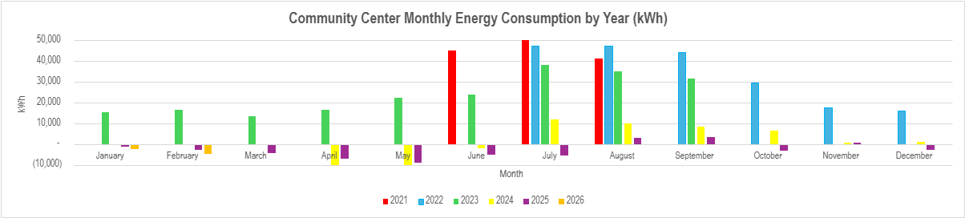

Figure 11: Community Center Building Monthly Energy Consumption by Year
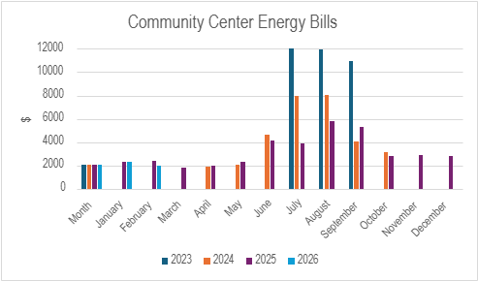

Morongo Administration Building
12700 Pumarra Rd.
Account # 700875505270; Contract #: 8017537904
Rate: TOU-GS-3D
Solar Online Date: Mar 13, 2024

The following presents the load assessment for the Administration Building; see Figure 12 for monthly energy consumption. The values shown reflect net energy consumption after accounting for solar generation and represent the usage recorded on SCE bills. Available billing data is limited for the period from 2021 through 2024; however, it clearly illustrates a significant reduction in energy consumption following the installation of the solar system in 2024. The difference in usage before and after solar installation is substantial.
In 2025, the solar system consistently overproduces from April through July, resulting in periods of net energy export. Overall, there is a significant reduction in energy consumption when comparing pre-solar years (2021–2023) to post-solar performance beginning in 2024. Figure 13 presents the monthly energy bills. While a full set of billing data was not available for 2023, the available data indicates that energy costs were substantially higher in 2023. For example, bills in July and August 2023 were just under $30,000, whereas in July 2025 they decreased to approximately $8,500 and in August 2025 to about $12,000. Total energy consumption for 2025 was 109,563 kWh, with total energy costs of $120,704. Monthly peak demand ranged from approximately 140 kW to 296 kW, with a maximum of 296 kW recorded in September.
Figure 12: Admin Building Monthly Energy Consumption by Year
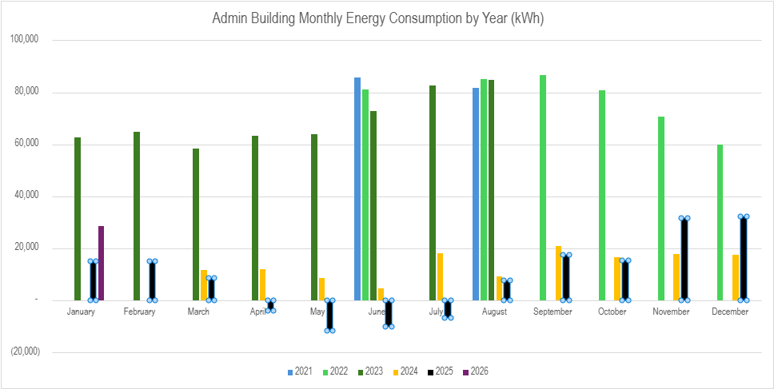
Figure 13: Admin Building Monthly Energy Consumption by Year
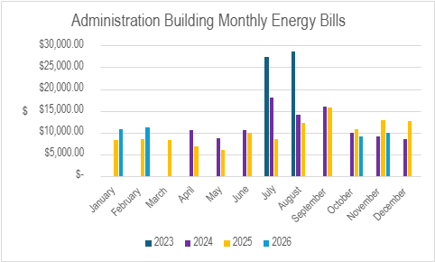

Residential Loads
Energy bills were analyzed for Morongo residents for 14 customers, see Table 5 below for a summary of energy consumption for 2024. Note the average annual energy consumption for Morongo residents is approximately 7,024 kWh.
Figure 14 illustrates the hourly energy consumption profiles for five different customers at Morongo over a 24-hour period on January 15, 2024. Overall, the load profiles show relatively stable overnight consumption across most customers, generally ranging between approximately 0.25 kW and 0.40 kW, indicating consistent baseline (non-discretionary) loads such as refrigeration, standby equipment, and essential appliances.
A noticeable drop in consumption occurs in the early morning hours (approximately 7:00 AM to 10:00 AM) for several customers, with some loads decreasing to near zero. This likely reflects periods when occupants leave their homes or reduce usage as part of daily routines. Midday consumption remains relatively low and steady for most customers, suggesting limited daytime occupancy or minimal active energy use during these hours.
In the late afternoon to evening period (approximately 4:00 PM to 9:00 PM), energy consumption increases across all customers, returning to or exceeding baseline levels. This pattern is consistent with typical residential behavior, where occupants return home and energy use increases due to lighting, cooking, HVAC, and appliance usage. One customer exhibits a consistently higher and flatter load profile throughout the day, indicating either continuous equipment operation or higher base load requirements compared to the others.
Table 5: 2024 Residential Energy Consumption, kWh
 | Annual Consumption, kWh
Customer 1 | 9,277
Customer 2 | 5,125
Customer 3 | 6,800
Customer 4 | 5,050
Customer 5 | 6,350
Customer 6 | 5,133
Customer 7 | 5,067
Customer 8 | 16,537
Customer 9 | 5,183
Customer 10 | 5,040
Customer 11 | 5,052
Customer 12 | 3,385
Customer 13 | 6,637
Customer 14 | 13,702

Figure 14: Hourly Energy Demand for 5 MBMI Residents, Jan 15, 2024
